**HTML**

HTML is the standard markup language for Web pages.

With HTML you can create your own Website.

HTML is easy to learn

**What is HTML ?**

HTML (HyperText Markup Language) is the standard language used to create and design webpages. It structures content on the web using a system of tags or elements. These tags define different parts of a webpage, such **as headings, paragraphs, links, images,** and more.

HTML elements tell the browser how to display the content

HTML is primarily used to develop **static web pages**. A static web page is a webpage that displays the same content for every user and doesn't change unless manually updated. HTML defines the structure of these pages by using tags to create elements like text, images, links, and forms.

**Key Concepts in HTML:**

* **Tags:** HTML uses tags to mark up content. For example, <p> is used to define a paragraph, and <h1> is used to define the largest heading.
* **Elements:** An HTML element consists of an opening tag, content, and a closing tag. For example, <p>This is a paragraph.</p>.
* **Attributes:** Tags can have attributes that provide additional information, such as specifying a link's URL with the href attribute in the <a> tag: <a href="https://example.com">Click Here</a>.

**HTML History**

HTML was initially created by **Tim Berners-Lee** in 1991 as a way to share and structure documents on the web.



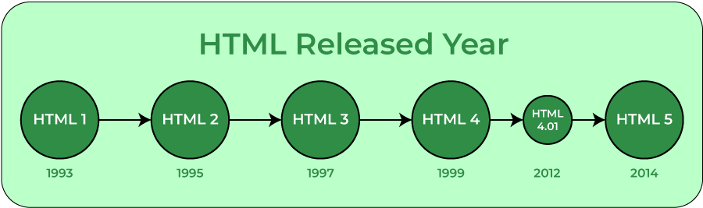

**Advantages of HTML**

* HTML is used to build websites.
* It is supported by all browsers.
* It can be integrated with other languages like [CSS](https://www.geeksforgeeks.org/css/), [JavaScript](https://www.geeksforgeeks.org/javascript/), etc.

**Disadvantages of HTML**

* HTML can only create static web pages. For dynamic web pages, other languages have to be used.
* A large amount of code has to be written to create a simple web page.
* The security feature is not good.